**Module 5 Data basse**

**Q1**

**ANS**

CREATE DATABASE Database_Assignment

CREATE TABLE Student

(

RollNo int PRIMARY KEY AUTO_INCREMENT,

Name varchar(50),

Branch varchar(80)

);

INSERT INTO student(Name,Branch) VALUES ('Jay','Computer Science');

INSERT INTO student(Name,Branch) VALUES ('Suhani','Electronic and Com');

INSERT INTO student(Name,Branch) VALUES ('Krim','Electronic and Com');

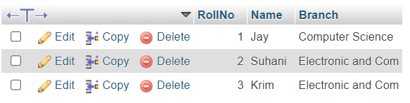

CREATE TABLE Exam

CREATE TABLE Exam(

Rollnu int,

S_code varchar(50),

Marks varchar(50),

P_code varchar(50),

FOREIGN key(Rollnu) REFERENCES student(RollNu)

);

INSERT INTO exam (Rollnu,S_code,Marks,P_code) VALUES ('1','CS11','50','CS');

INSERT INTO exam (Rollnu,S_code,Marks,P_code) VALUES ('1','CS12','60','CS');

INSERT INTO exam (Rollnu,S_code,Marks,P_code) VALUES ('2','EC101','66','EC');

INSERT INTO exam (Rollnu,S_code,Marks,P_code) VALUES ('2','EC102','70','EC');

INSERT INTO exam (Rollnu,S_code,Marks,P_code) VALUES ('3','EC101','45','EC');

INSERT INTO exam (Rollnu,S_code,Marks,P_code) VALUES ('3','EC102','50','EC');

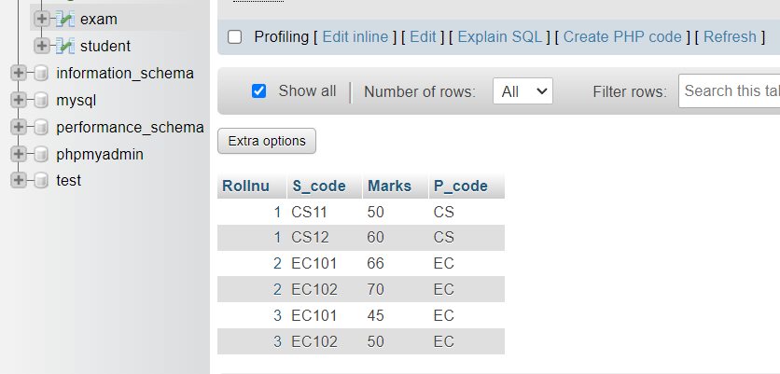

**Q2**

**ANS**

INSERT into cartoon (First_Name,Last_Name,Address,City,Age) VALUES ('Mikey','Mouse','123 Fantasy Way','Anaheim','73');

INSERT into cartoon (First_Name,Last_Name,Address,City,Age) VALUES ('Bat','Man','321 Cavern Ave','Gotham','54');

INSERT into cartoon (First_Name,Last_Name,Address,City,Age) VALUES ('Wonder','Woman','987 Truth Way','1paradise','39');

INSERT into cartoon (First_Name,Last_Name,Address,City,Age) VALUES ('Donald','duck','555 Quack Street','Mallard','65');

INSERT into cartoon (First_Name,Last_Name,Address,City,Age) VALUES ('Bugs','Bunny','567 Carot Street','Rascal','58');

INSERT into cartoon (First_Name,Last_Name,Address,City,Age) VALUES ('Wiley','Coyet','999 Acme Way','Anaheim','73');

INSERT into cartoon (First_Name,Last_Name,Address,City,Age) VALUES ('Cat','Woman','234 Purffect Street','Hairball','32');

INSERT into cartoon (First_Name,Last_Name,Address,City,Age) VALUES ('Tweety','Bird','543','Itotital','28');

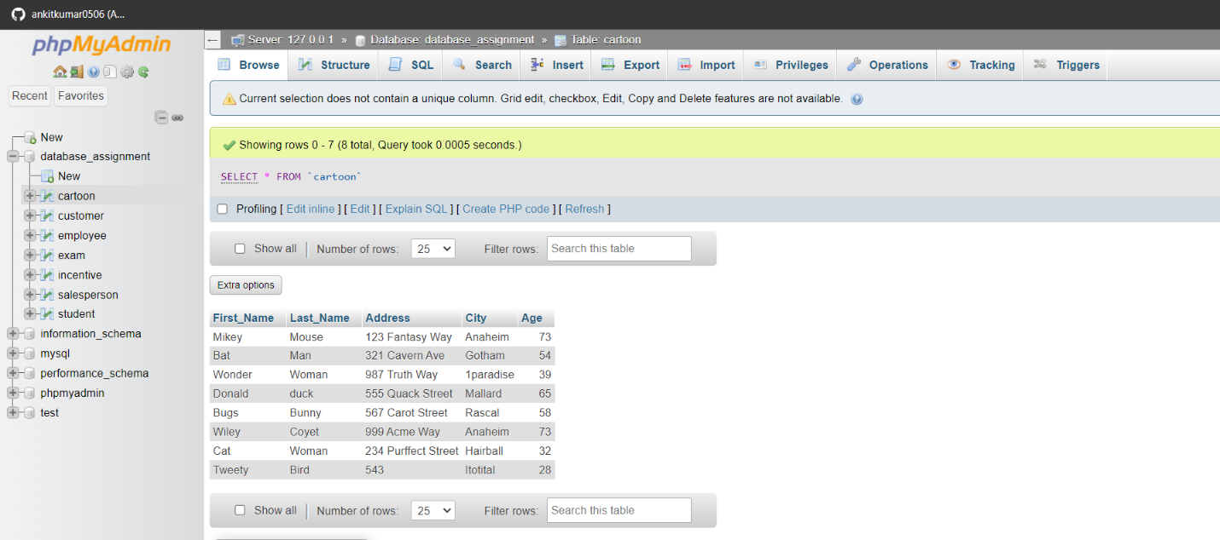

**Q3.** Create table given below: Employee and Incentive

Table Name: Employee

INSERT into employee (First_name,Last_name,salary,Joining_date,Department) VALUES('John','Abraham','1000000','01-JAN-13 12:00:00 AM','Banking');

INSERT into employee (First_name,Last_name,salary,Joining_date,Department) VALUES('Michael','clarke','8000000','01-JAN-13 12:00:00 AM','Insurance');

INSERT into employee (First_name,Last_name,salary,Joining_date,Department) VALUES('Roy','Thomas','7000000','01-FEB-13 12:00:00 AM','Banking');

INSERT into employee (First_name,Last_name,salary,Joining_date,Department) VALUES('Tom','Jose','6000000','01-JAN-13 12:00:00 AM','Insurance');

INSERT into employee (First_name,Last_name,salary,Joining_date,Department) VALUES('Jerry','Pinto','6500000','01-JAN-13 12:00:00 AM','Insurance');

INSERT into employee (First_name,Last_name,salary,Joining_date,Department) VALUES('Philip','Mathew','7500000','01-JAN-13 12:00:00 AM','Services');

INSERT into employee (First_name,Last_name,salary,Joining_date,Department) VALUES('TestName1','123','6500000','01-JAN-13 12:00:00 AM','Services');

INSERT into employee (First_name,Last_name,salary,Joining_date,Department) VALUES('Testname2','Lname%','6000000','01-

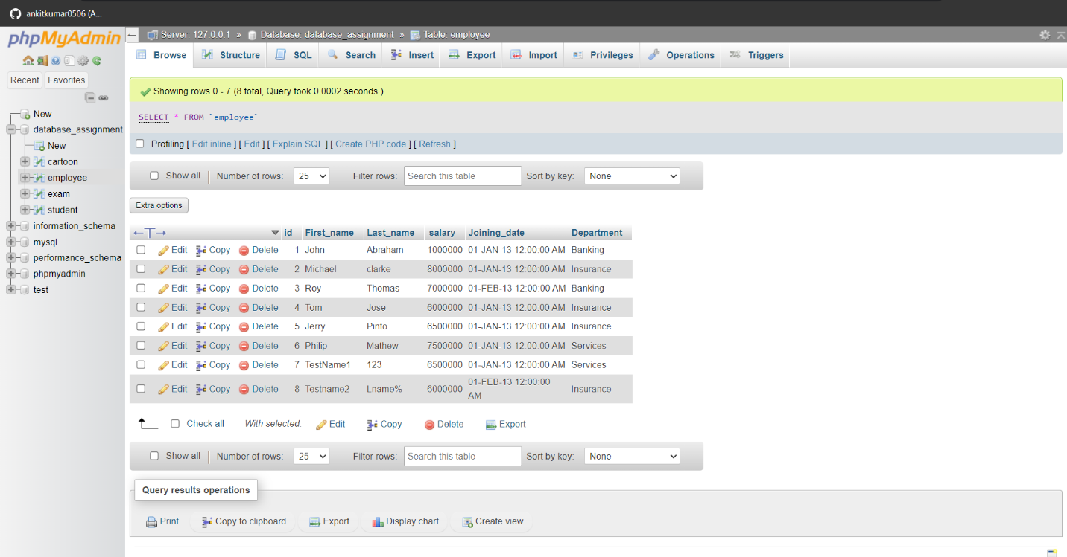

**Table Name: Incentive:**

CREATE TABLE Incentive( Employee_Ref_ID INT, Incentive_Date VARCHAR (20), Incentive_Amount INT, FOREIGN KEY (Employee_Ref_ID) REFERENCES employee (Employee_ID) );

INSERT INTO incentive (Employee_Ref_ID, Incentive_Date, Incentive_Amount) VALUES(1,'01-FEB-13',5000);

INSERT INTO incentive (Employee_Ref_ID, Incentive_Date, Incentive_Amount) VALUES(2,'01-FEB-13',3000);

INSERT INTO incentive (Employee_Ref_ID, Incentive_Date, Incentive_Amount) VALUES(3,'01-FEB-13',4000);

INSERT INTO incentive (Employee_Ref_ID, Incentive_Date, Incentive_Amount) VALUES(1,'01-JAN-13',4500);

INSERT INTO incentive (Employee_Ref_ID, Incentive_Date, Incentive_Amount) VALUES(1,'01-JAN-13',3500);

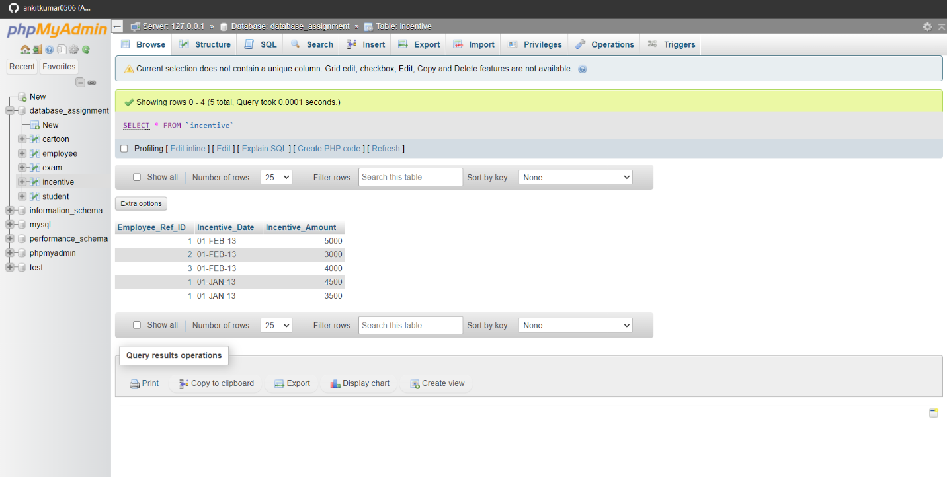

A)Get First_Name from employee table using name “Employee Name”.

ans. SELECT First_Name FROM employee;

B)Get FIRST_NAME, Joining Date, and Salary from employee table.

ans. SELECT First name, Joining Date, Salary FROM employee;

C)Get all employee details from the employee table order by First_Name Ascending and Salary descending?

ans. SELECT First_name, Salary FROM employee ORDER BY First_Name ;

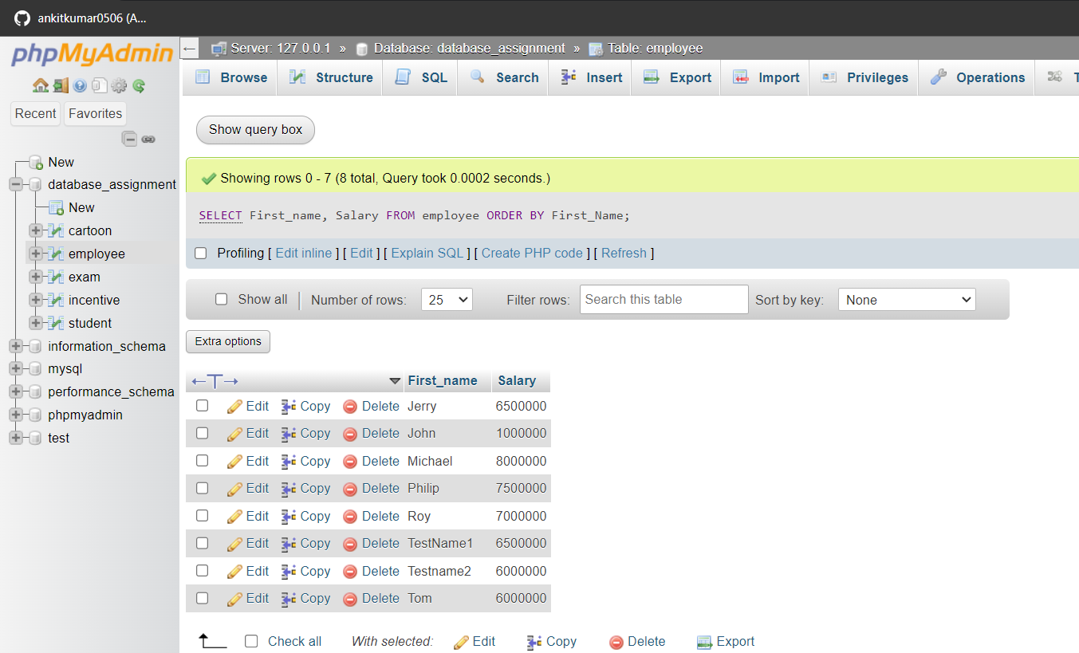

d) Get employee details from employee table whose first name contains ‘J’.

ans. SELECT First_Name FROM employee WHERE First_Name LIKE ‘J%’;

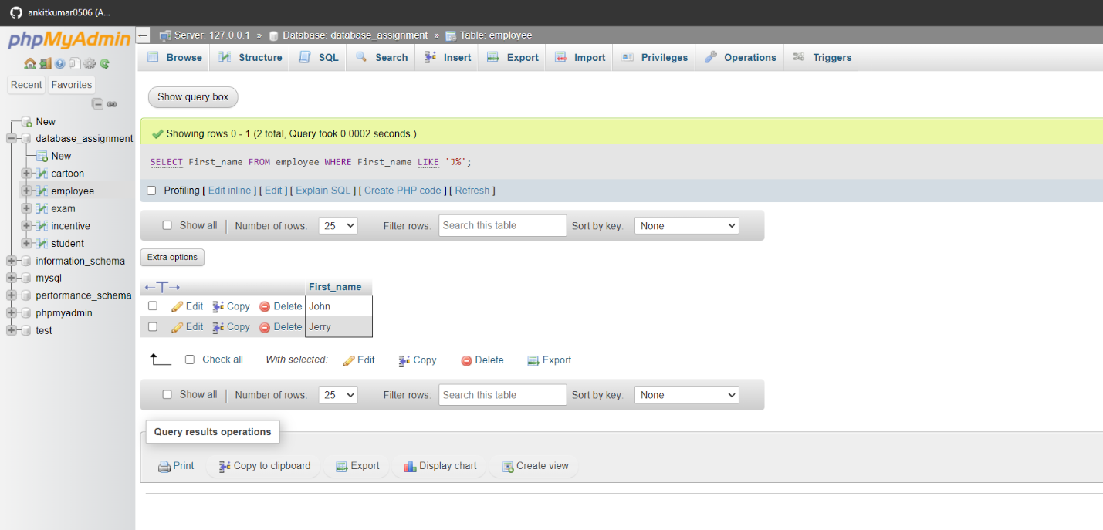

**Q4**. Create table given below: Salesperson and Customer

CREATE TABLE salesperson

( SNo int PRIMARY key AUTO_INCREMENT,

SNAME VARCHAR (50),

CITY VARCHAR (50),

COMM INT

); 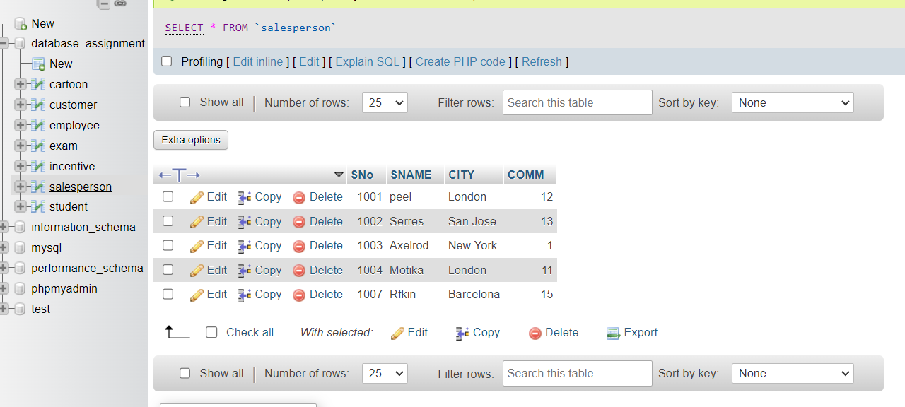

CREATE TABLE customer

(

CNM INT PRIMARY KEY,

CNAME VARCHAR (20),

CITY VARCHAR (20),

RATING INT,

SNo INT,FOREIGN KEY (SNo) REFERENCES salesperson (SNo)

);

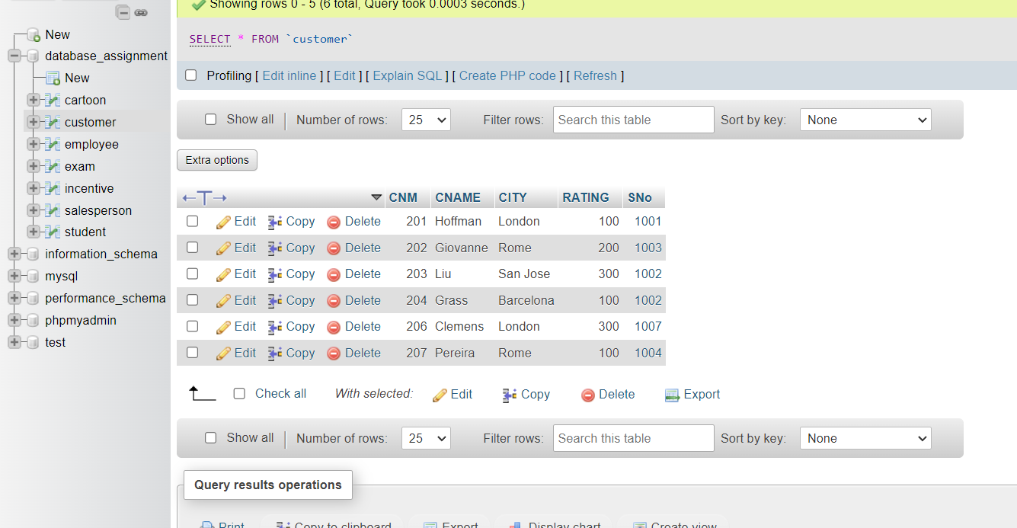

INSERT INTO customer (CNM, CNAME, CITY, RATING, SNo) VALUES ('201', 'Hoffman', 'London', '100', '1001'), ('202', 'Giovanne', 'Rome', '200', '1003'), ('203', 'Liu', 'San Jose', '300', '1002'), ('204', 'Grass', 'Barcelona', '100', '1002'), ('206', 'Clemens', 'London', '300', '1007'), ('207', 'Pereira', 'Rome', '100', '1004');

A)All orders for more than $1000.

Ans. SELECT * FROM customer WHERE SNo>1000;

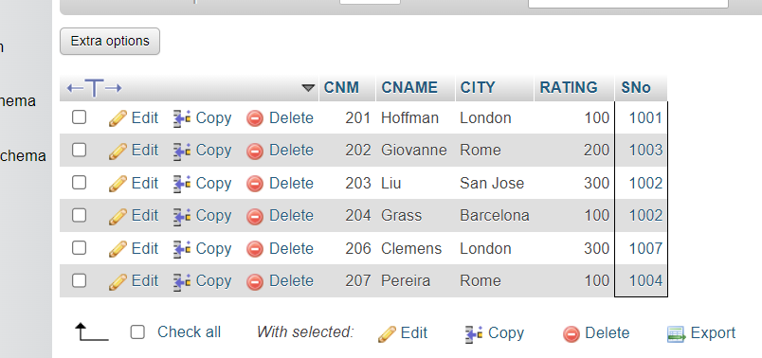

b) Names and cities of all salespeople in London with commission above 0.12

Ans. SELECT * FROM salesperson WHERE COMM>.12;

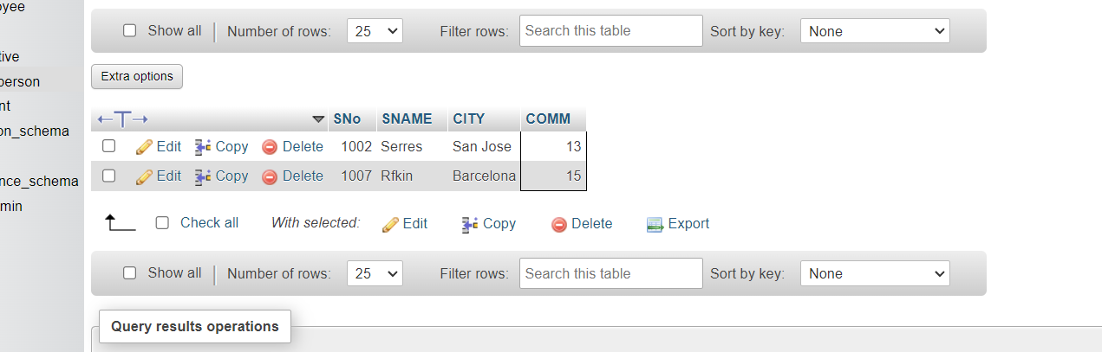

c) All salespeople either in Barcelona or in London

ans. SELECT * FROM salesperson WHERE CITY='Barcelona' OR CITY='London';

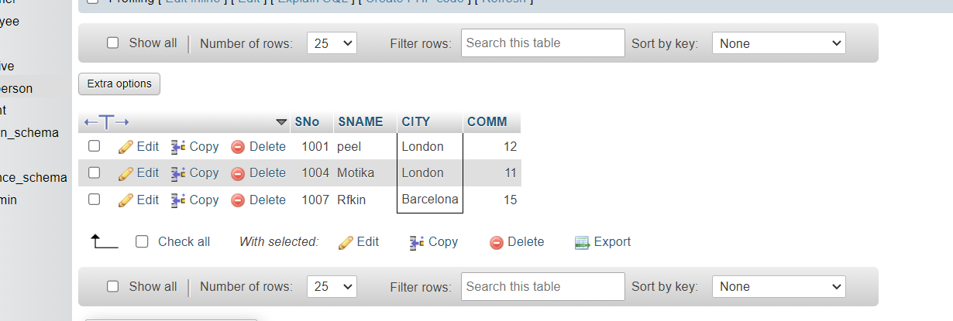

d) All salespeople with commission between 0.10 and 0.12. (Boundary values should be excluded).

Ans. SELECT * FROM salesperson WHERE COMM BETWEEN .10 AND 0.12;

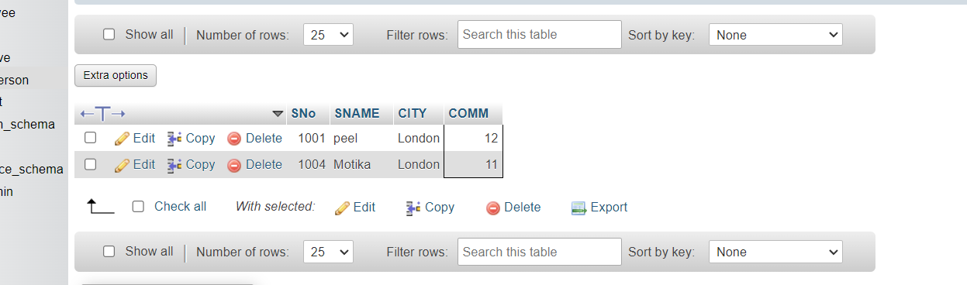

e) All customers excluding those with rating <= 100 unless they are located in Rome

Ans. SELECT * FROM customer WHERE RATING<=100 OR CITY='Rome';

